**Validation of a Multi-Sensor Drugs Detection Platform in Plasma for Point-of-Care technology**

**Contacts:** [Francesca Rodino](https://people.epfl.ch/francesca.rodino/?lang=en) (francesca.rodino@epfl.ch)

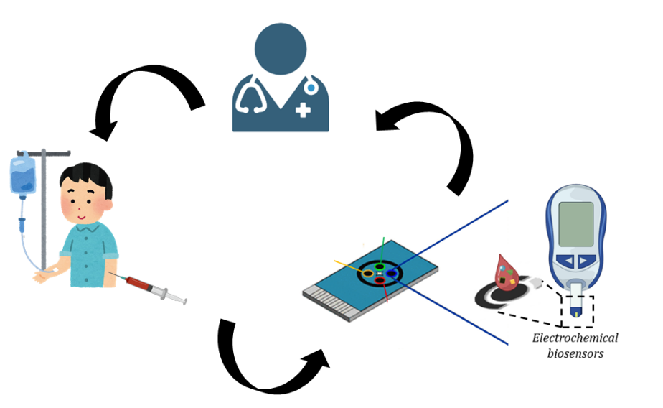 [Sandro Carrara](mailto:Sandro%20Carrara) (sandro.carrara@epfl.ch)

**Introduction**

Therapeutic drug monitoring (TDM) is crucial for achieving more precise and personalized medicine, as it accounts for individual differences in metabolism, drug absorption, and response. To this end, real-time monitoring of drug concentrations is crucial to tailoring treatments effectively.

Point-of-care (POC) technologies offer an ideal solution for TDM. In this context, biosensors play a pivotal role by providing rapid and accurate measurements of drug levels in the bloodstream. To ensure precision in TDM, these sensors must be highly sensitive and specific to different drugs.

Validation in plasma is essential for biosensors intended for point-of-care use, as it ensures accuracy, reliability and clinical relevance by testing sensor performance in the actual sample matrix in the medical field.

**Project Description:**

This project aims to develop innovative point-of-care systems utilizing electrochemical sensors and biosensors for therapeutic drug monitoring (TDM) in oncological patients, targeting personalized medicine. The goal of this project is to test biosensors or a biosensor array for anticancer drugs detection in plasma to characterize biosensors’ performances in real-case scenarios. This can be followed by the integration of a simple microfluidic system based on paper fluidics for blood/plasma separation.

**Topics:**

* Testing of the biosensors with different anticancer drugs in plasma
* Samples preparation
* Comparison of the performances between PBS buffer and plasma
* Simultaneous detection of multiple drugs
* Microfluidics integration

**Requirements:**

* Basic knowledge of electrochemistry
* Basic knowledge of biosensors systems
* Some knowledge of simple microfluidics systems
* Interest, Motivation, and Commitment to the project

**References:**

[1] Rodino, Francesca, Mattia Bartoli, and Sandro Carrara. "Simultaneous and selective detection of etoposide and methotrexate with single electrochemical sensors for therapeutic drug monitoring." IEEE Sensors Letters (2023).

[2] Baj-Rossi, Camilla, Giovanni De Micheli, and Sandro Carrara. "Electrochemical detection of anti-breast-cancer agents in human serum by cytochrome P450-coated carbon nanotubes." Sensors 12.5 (2012): 6520-6537.