<Cold start>

* Turn on the chiller for 30min at 26C
* Power plug in (crystal starts to get heated) wait 30min
* Turn on the power switch (red toggle switch) wait 5min
* Press the shutter button (now ON)
* Turn the enable key (now ON)
* Turn on the LDD (now ON)
* Change the current to 20A. Wait 5min.
* Change the current to 33.2A.
* Now ready.

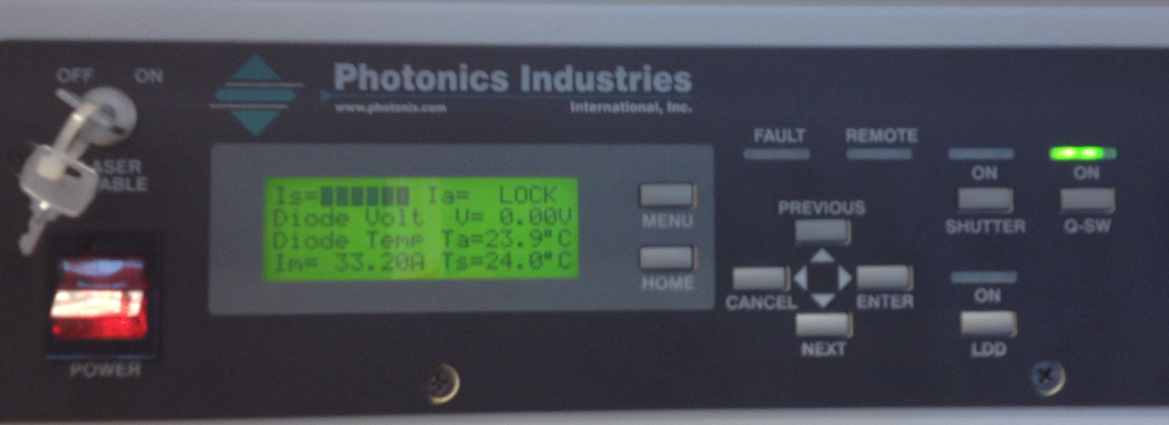

<Cold off>

* Change the current to 0A
* Press LDD (now OFF)
* Turn the enable key (now OFF)
* Press the shutter button (now OFF)
* Power toggle switch off
* Unplug the power cord
* Chiller off

<Warm off>

* Change the current to 0A
* Press LDD (Now OFF)
* Press the shutter key (now OFF)
* Power toggle switch off
* Chiller (can stay on or off)

<Warm Start>

* Chiller on if it was off
* Power switch on
* Press Shutter key on
* Press LDD (Now ON)
* Change the current to 20A. Wait 5min.
* Change the current to 33.2A.