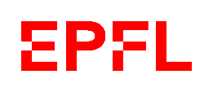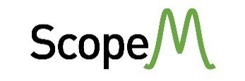

**Advanced Characterization of Materials at Micro-, Nano- and Atomic Scale**

4 – 7 November 2024, ETH Zurich, Campus Hönggerberg

**Focused Ion Beam (FIB): Fundamentals and Applications**

Joakim Reuteler

ETH Zürich, ScopeM

Abstract

Focused Ion Beam (FIB) technology allows for both sample characterization as well as sample preparation for other techniques. Modern FIB instruments are combined microscopes offering an SEM column and a FIB column mounted on the same sample chamber (FIBSEM). This combination enables a large variety of applications: nanopatterning, cross section analysis, TEM lamella preparation, 3-d imaging and micropillar preparation to name a few.

This lecture covers aspects of ion-solid interaction relevant for understanding the mechanisms of FIB milling, deposition and enhanced etching. The peculiarities of different ion species and the corresponding ion sources are explained. Geometrical aspects of FIBSEM instrumentation relevant for practical work as well as several popular FIBSEM applications are presented. For the latter the typical workflow, some artifacts and tricks to overcome them as well as alternative approaches are discussed.

Contact details

E-mail: [joakim.reuteler@scopem.ethz.ch](mailto:joakim.reuteler@scopem.ethz.ch)

Phone : +41 (0) 44 633 6991

<https://scopem.ethz.ch/>